**Topics: Descriptive Statistics and Probability**

1. Look at the data given below. Plot the data, find the outliers and find out $μ, σ, σ^{2}$

|  |  |
| --- | --- |
| **Name of company** | **Measure X** |
| Allied Signal | 24.23% |
| Bankers Trust | 25.53% |
| General Mills | 25.41% |
| ITT Industries | 24.14% |
| J.P.Morgan & Co. | 29.62% |
| Lehman Brothers | 28.25% |
| Marriott | 25.81% |
| MCI | 24.39% |
| Merrill Lynch | 40.26% |
| Microsoft | 32.95% |
| Morgan Stanley | 91.36% |
| Sun Microsystems | 25.99% |
| Travelers | 39.42% |
| US Airways | 26.71% |
| Warner-Lambert | 35.00% |

Answer:- Code

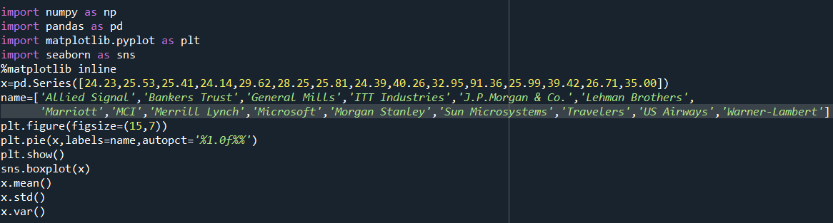

Output:-

1. Pie Plot:-

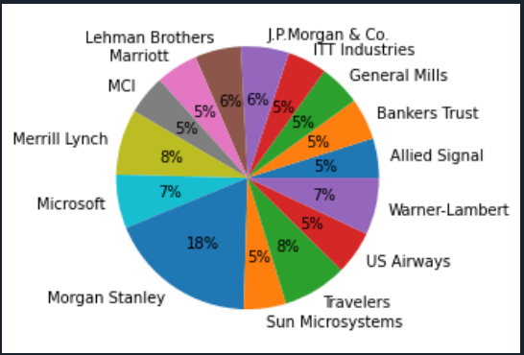

Using pie plot we can visualize and understand the percentages which represent the proportions of different categories within the given dataset. Higher the percentage 🡪 higher the proportion.

1. BoxPlot:-

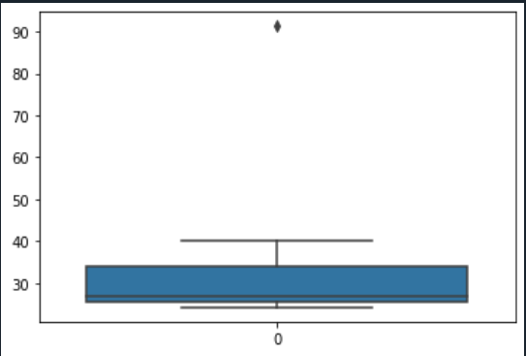

The boxplot is used to visualize the data and find out the outliers . In the above boxplot of the given data, we can say that the outlier is above the maximum value as it is **1.5 times the IQR** greater than Q3. We can also calculate the boundaries for potential outliers, for the above outlier we can calculate using the upper boundary.

3)Calculating the mean, variance and standard deviation:

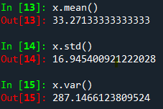



Answer the following three questions based on the box-plot above.

1. **What is inter-quartile range of this dataset? (please approximate the numbers) In one line, explain what this value implies.**

Answer:-

let’s say the first quartile range (Q1) =5

The third quartile range(Q3) = 12

IQR( inter- quartile range) = 7, which is also the median value.

It also consists of an outlier above the maximum value at 25.

1. **What can we say about the skewness of this dataset?**

Answer:-

we can say that it is a right skewed. And the median is on the left side, so it does not follow a normal distribution.

1. **If it was found that the data point with the value 25 is actually 2.5, how would the new box-plot be affected?**

Answer:-

It might have followed a normal distribution without outliers, as the outlier in the above boxplot is positively skewed it can be reduced and hence the data might be distributed normally.



Answer the following three questions based on the histogram above.

1. **Where would the mode of this dataset lie?**

Answer:- approximately, the mode lies in between 4 to 8 (or) in between 5 to 10.

1. **Comment on the skewness of the dataset.**

Answer:- The data set is positively skewed, as the peak is on the left. In a positively skewed data the mean is said to be greater than median (MEAN>MEDIAN>MODE).

1. **Suppose that the above histogram and the box-plot in question 2 are plotted for the same dataset. Explain how these graphs complement each other in providing information about any dataset.**

Answer:- Both the histogram and the box plot are right-skewed and have an outlier, the median can be visualized in the boxplot where as in the histogram it is more visible.

1. AT&T was running commercials in 1990 aimed at luring back customers who had switched to one of the other long-distance phone service providers. One such commercial shows a businessman trying to reach Phoenix and mistakenly getting Fiji, where a half-naked native on a beach responds incomprehensibly in Polynesian. When asked about this advertisement, AT&T admitted that the portrayed incident did not actually take place but added that this was an enactment of something that “could happen.” Suppose that one in 200 long-distance telephone calls is misdirected. What is the probability that at least one in five attempted telephone calls reaches the wrong number? (Assume independence of attempts.)

Answer:- Code

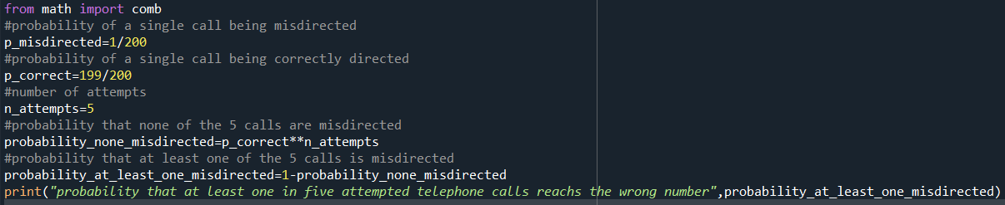

Output:-

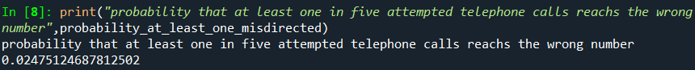

1. Returns on a certain business venture, to the nearest $1,000, are known to follow the following probability distribution

|  |  |
| --- | --- |
| x | P(x) |
| -2,000 | 0.1 |
| -1,000 | 0.1 |
| 0 | 0.2 |
| 1000 | 0.2 |
| 2000 | 0.3 |
| 3000 | 0.1 |

1. What is the most likely monetary outcome of the business venture?

Answer:- code

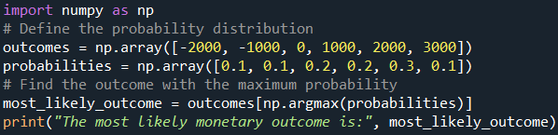

Output:-



1. Is the venture likely to be successful? Explain

Answer:- Code

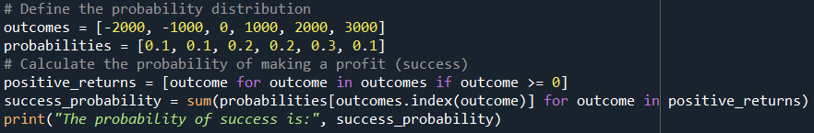  
Output:-

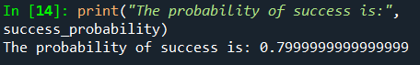

1. What is the long-term average earning of business ventures of this kind? Explain

Answer:- code

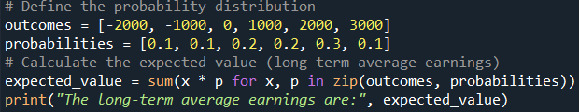

Output:-

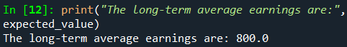

1. What is the good measure of the risk involved in a venture of this kind? Compute this measure

Answer:- code

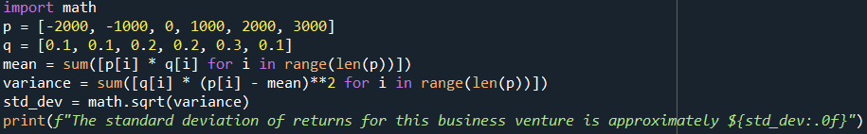

Output:-

